Diversity in Biology
A guide to making your biology curriculum inclusive of LGBT+ identities compiled and edited by Space Youth Project.

Space Youth Project supports young LGBT+ people under the age of 25 with youth groups across Dorset. For many years now, the organisation has been visiting schools in order to train staff and educate students about diversity in gender, sex and relationships.
One thing that staff have made clear is the need for guidance with diversity in biology.
The following is a guide to diversity in the secondary biology curriculum.
If you believe something needs to be corrected, please email education@spaceyouthproject.co.uk and it will be updated.

Contents:
- Stonewall Guidance
- Tips from a Trans Teacher
- Emily Quinn Intersex Ted Talk
- Language Guide
- Resources

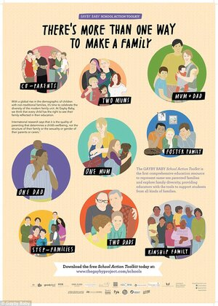

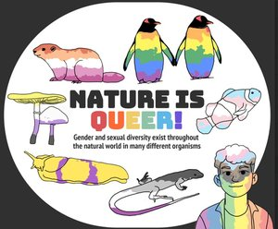

Stonewall guidance-

The following information as well as a lesson plan can be found at: CREATING AN LGBT-INCLUSIVE CURRICULUM

Making science LGBT-inclusive requires a straightforward approach. LGBT people have made vital contributions to the field of science and related disciplines, and science lessons provide an excellent opportunity to celebrate them. Take the opportunity to challenge gender stereotypes and ensure that any teaching on relationships and sex is inclusive of LGBT people.

Key ways to go about it-
- Use inclusive language and examples: Use language and examples that include LGBT people when setting questions. For example, ‘two women would like to have a baby together, and the doctor recommends they use In Vitro Fertilisation (IVF)’.
- Discuss sexual orientation and gender in an objective way: Use factual information to talk about sexual orientation and gender in a non-emotional, non-judgemental way. Talk about same-sex attraction as a natural fact in other species and draw out examples of family diversity across species. For example, ask pupils to examine species where male parents take the primary role of caring for and raising their children
- Highlight LGBT scientists and figures in related disciplines: Include LGBT scientists or figures in related disciplines (such as Francis Bacon or Louise Pearce) and highlight the contributions they have made to the field of science. Invite a Stonewall School Role Model with a STEM background to speak to pupils about their work and experiences.
- Explore gender stereotypes and barriers to participation in science, technology, engineering and mathematics (STEM) subjects: Discuss how gender stereotyping can act as a barrier to participation in STEM subjects, and link them to the negative impact they can have on LGBT people. Work with the careers department to arrange visits from people from a range of backgrounds working in STEM careers and encourage pupils to take on work experience placements in STEM workplaces.

Teaching about relationships and sex in science lessons:
Stonewall’s 2017 School Report found that just one in five LGBT pupils had been taught at school about safe sex and contraception in relation to same-sex relationships. Without information in this area, LGBT young people are less likely to feel equipped to practice safe sex and are more likely to feel isolated and take risks. It is therefore vital that teaching about sex and relationships in biology takes into account the needs of LGBT pupils. To do this:

- Ensure your school’s relationships and sex education (RSE) policy explicitly refers to LGBT people.
- Deliver content with LGBT pupils in mind, for instance by using language that includes different kinds of relationships (for example, use partner instead of boyfriend/girlfriend) and avoiding the assumption that pupils will only be attracted to people of a different gender.
- Refer to different types of sex, including same-sex sex, and talk about different ways to practice safe sex.
- Provide a range of information and signposting to pupils that is inclusive of LGBT people. Suggestions can be found in Stonewall’s guide, An introduction to supporting LGBT young people, available online.

Tips from a Trans Teacher-

The rest of the article can be found at: https://www.glsen.org/blog/6-ways-i-make-my-science-class-lgbtq-inclusive-trans-teacher
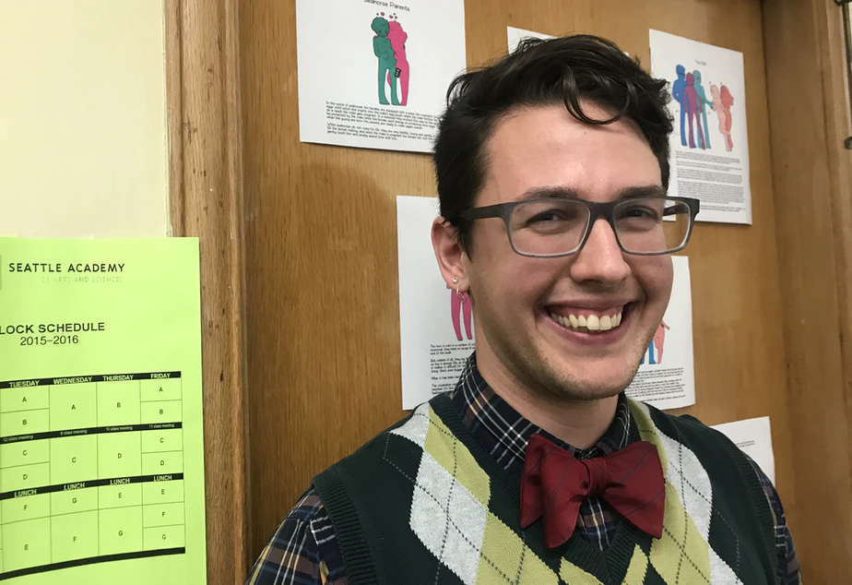
Lewis Maday-Travis is a Trans-male teacher teaching students aged 13-14. The following information is from an article he published on how he makes his science class LGBTQ inclusive.

- As much as possible, I use examples of diversity among the reproductive strategies of different species to highlight ways that heteronormative assumptions about biology and evolution are unfounded. Images by the artist Humon are on my wall at school, and kids love reading about the diversity of animals’ courtship behavior. I also use an activity about reproductive behavior during our unit on gender, sex, and sexuality to underscore the diverse strategies species use to reproduce.
- When discussing genitalia in my classes, students model the development of proto-genitals in utero using clay. All genitals start as the same core parts, and diverge depending on genetic and hormonal factors in the uterus. Going through the stages of genital development is not only useful for thinking about homologous structures, but also helps students start to think about the diversity of genitalia, including genitals that are not strictly a penis/scrotum or a vulva.
- I try to teach sex ed without assumptions about who students might have sex with — or that they might have sex at all. Increasing asexual and aromantic visibility has led me to challenge many of the assumptions I made in the past about how to frame sexual health education. Though sexuality education is important for all students, not all students will have sex in their lifetimes, and not all students are interested in sex with anyone, let alone a person with any particular genital or gender configuration.
- Talking about intersex experiences in a way that is normalizing and not voyeuristic is incredibly important in breaking down notions of fixed “biological sex.” We discuss a variety of ways that chromosomal variation can lead to differences in the way a person is assigned a sex at birth. I also emphasize the differences between the experiences of intersex people and that of transgender people with my students, since the two communities face different issues regarding sex, health access, and gender identity/expression.
- I teach using case studies, specific and complex stories from medicine that students use to learn about a particular body system or concept. Whenever I write a case study for my classroom, I try to write them in ways that normalize queer and trans experiences and families. Just the act of including a queer or trans person in a story — without tokenizing them or making the whole story about their queer or trans identity — sends a clear message to students about what is normal and valued in the classroom. A friend of mine also does a case study in his classroom that traces the experience of an intersex adolescent experiencing a normative health class. The story traces the emotional experience of the student while also educating students about the ways that student’s biology fits into what they already know about chromosomal combination and organ structure and function.

Emily Quinn - Intersex Ted Talk

Emily Quinn describes herself as "a ballsy intersex activist who uses humor and storytelling to create a more welcoming world for people who don’t fit in a box." :
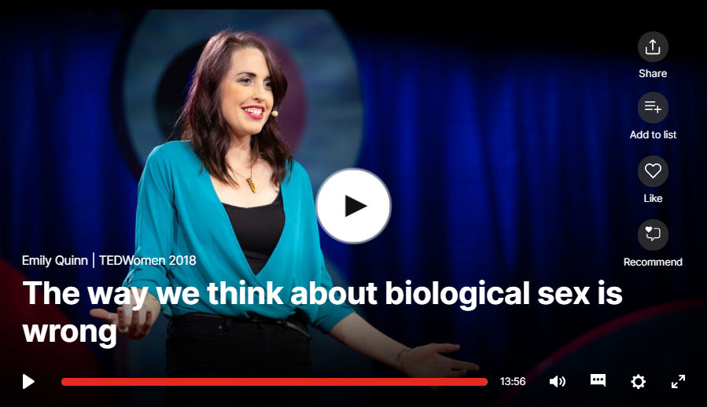
Did you know that almost 150 million people worldwide are born intersex -- with biology that doesn't fit the standard definition of male or female? (That's as many as the population of Russia.) At age 10, Emily Quinn found out she was intersex, and in this wise, funny talk, she shares eye-opening lessons from a life spent navigating society's thoughtless expectations, doctors who demanded she get unnecessary surgery -- and advocating for herself and the incredible variety that humans come in. (Contains mature content)

https://www.ted.com/talks/emily_quinn_the_way_we_think_about_biological_sex_is_wrong

Language Guide
The following has been adapted from: https://www.genderinclusivebiology.com/bettersciencelanguage

PHYSIOLOGY-
Instead of... | Try...
“Men produce sperm.”  “Males produce sperm.” | “Testes produce sperm.”
“Women produce eggs.”  “Females produce eggs.” | “Ovaries produce eggs.”
“When women menstruate, their bodies prepare the uterus for a fertilized egg to implant itself so a baby can form.” | “For those with ovaries, the pituitary glands and ovaries interact to start menstruation.”  “If you have ovaries, then you might begin to menstruate. Your pituitary glands may…”
“Boys and men produce sperm every day.” | “For those with testicles, sperm cells are produced daily once puberty has begun.”
repeating “people with <body part>” | Avoid cumbersome or repetitive language by streamlining with “if you have a <body part>..., then your…”
“male or female hormones” | testosterone or estrogen  “______ is dominant.  “These lizards are only one sex, regulated by estrogen.”
“gender reveal party” | Consider removing this non-biologically essential activity from your curriculum. Cis- and transgender students alike have different relationships with their birthdays.  What essential standard do students learn from this that another activity offers? If you must, try relabeling as:  “embryogenesis party”  “chromosome reveal party”
“male reproductive organs” | “penis and testicles”
“female reproductive organs” | “Vulva, vagina, uterus, and ovaries”
“When the mum gives birth to the fetus or infant…” | “When the baby exits the womb…”
“mum” | “birth parent” “carrier”
“normal” / “natural” / “typical” | “most common,” “frequent,” or “many people / bodies / parts”
Genes
Instead of... | Try...
“Mom gave you her genes, Dad gave you his.” | “You received a mix of genes from sperm and egg.”
Evolution
Instead of... | Try...
“A major characteristic of life is reproduction. Things are alive if they reproduce.” | Your cells are always reproducing asexually within your body for growth and repair. Reproduction is required for a species, not an individual.
"The goal of every organism is to survive and reproduce" | Individuals who produce more offspring have their genes represented in the next generation at a higher number.
“Females choose the best genes.” | Organisms choose the best resources. In many mate choice systems, the egg producer must invest more biological resources than the sperm producer. Often the egg producers show preferences for certain traits. Scientists associate these traits with genes to infer the producers are choosing genes.
Sex Education (see tipsheet for genderinclusive sex ed)
Instead of... | Try...
“Women should get regular PAP tests.” | “People who have a cervix should get regular PAP tests.”
“Men should check their testicles regularly for lumps.” | “Testicle-having people should check them regularly for lumps”
“Guys, roll a condom onto your penis before you start having sex.” | “Use a condom on penises or sex toys.”
repeating “people with <body part>” | streamlining with “if you have a <body part>..., then your…”
“Men and boys ejaculate when…” | “Ejaculation happens when…”
“Women normally menstruate at age…” | “Menstruation most often begins at…”

Resources
- Graphics, Diagrams and images: https://www.genderinclusivebiology.com/posters-images
- Videos for students: https://www.genderinclusivebiology.com/videos
- Readings for students: https://www.genderinclusivebiology.com/articles-for-students
- Readings for staff: https://www.genderinclusivebiology.com/articles-for-educators
- Database of sexually diverse organisms: https://www.genderinclusivebiology.com/newsletter/evolutions-rainbow-a-queer-species-database-of-200-organisms
- Stonewall’s diversity in the secondary curriculum guide: CREATING AN LGBT-INCLUSIVE CURRICULUM
- 6 Ways I Make My Science Class LGBTQ-Inclusive as a Trans Teacher
- https://www.ted.com/talks/emily_quinn_the_way_we_think_about_biological_sex_is_wrong
- Language Guide: language guide — Gender-Inclusive Biology
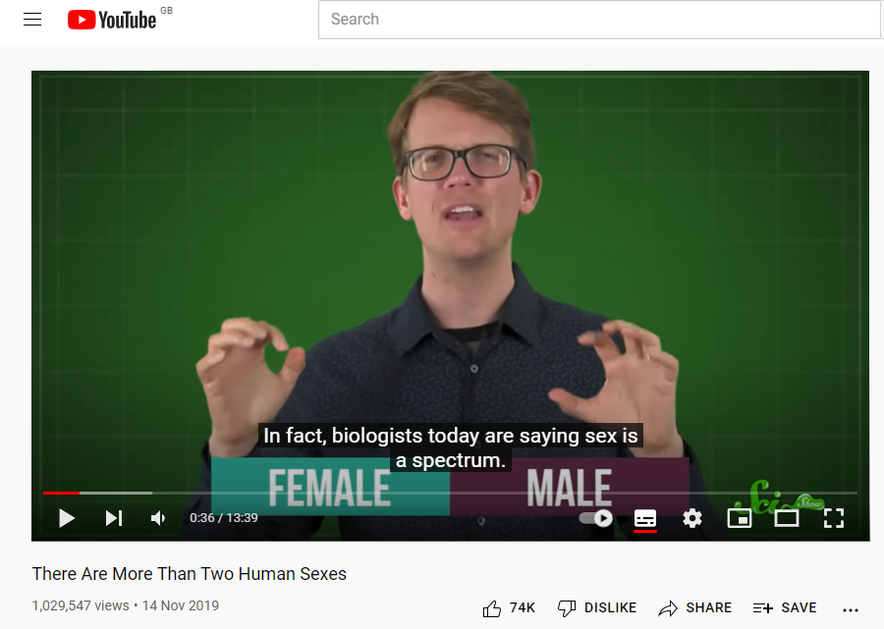
- Tip sheet for gender inclusive Sex Education: tipsheet for genderinclusive sex ed

