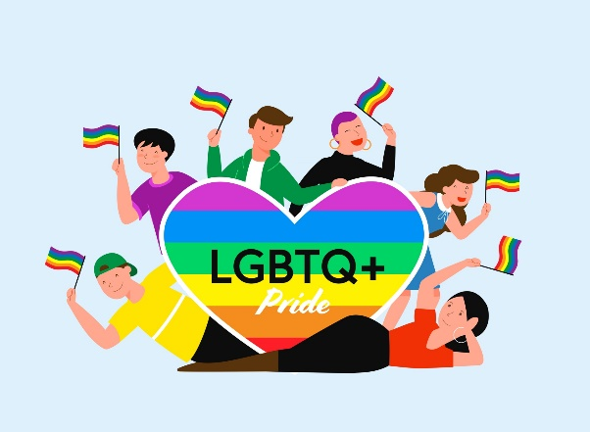
Top Tips for Running a Pride Group – Primary and Secondary
suggested by teachers who currently run Pride Groups in school

Suggestions for making it work/ dealing with any issues:
- Use the resources from JustLikeUs.org – they provide everything you need
- If there’s a problem with students and calling it a Pride Group, make it a Diversity Group and include anyone who wants to talk about diversity in different forms.
- Advertise the group with the day and time, but not the location – add a QR code or teacher email address for students to find out the location
- Advertise the group on screens if posters are being removed
- Promote teacher ally visibility throughout the school with lanyard/ stickers/ badges/ flags, etc.
- Consider your meeting place carefully – make it a room that’s a bit tucked away and not with big windows onto shared space – some students will want to be anonymous
- Remember that some students will need to walk past your group or say they are ‘just an ally’ for a while before they feel confident to come out
- Remember that this group can be a life-saver!
- Make a link with your pastoral team, so they can recommend the club to students who might want to go along.

Suggestions for activities:
- Design a logo for the group – graphics challenge?
- Invite the school librarian to come and showcase LGBT+ inclusive books and/or run a discrete book exchange service for students if required
- Hold a Pride Party
- Invite subject leaders to talk about how LGBT+ issues are included in their curriculum area, or ask students to suggest how they could be included to these teachers
- Decorate cakes with rainbow colours and hold a bake sale
- Make badges (plastic clip together ones can be found cheaply on the internet and don’t need a badge-maker
- Chill out by watching inclusive tv, such as Heartstopper
- Create a Pride Playlist
- Hold discussions on current affairs; become activists
- Hold a pride event in partnership with other local schools as a way to meet new people
- Learn about the history of the different LGBTQ+ flags and make your own versions
- Use lego to make Pride-related models
- Design speech bubble slogans or comments for around the school
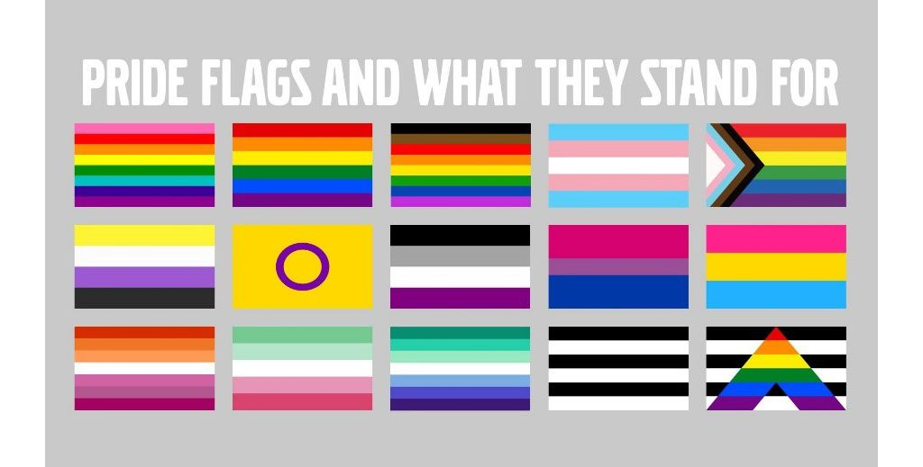
- Decorate tiles and make a display
- Research historical/ influential LGBTQ+ people
- Research the history of Pride
- Read and review LGBTQ+ books

